2026-2027
Senior Snow Removal Service Guidelines
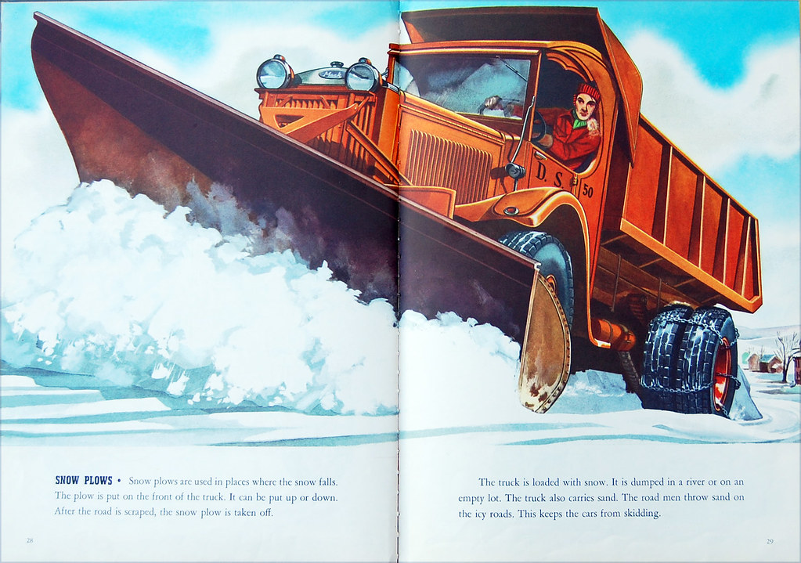

contractor.
Contractors will only plow once each snowfall. They will not return to clear drifts after snow has been plowed. Contractors will only plow up to and not next to vehicles in the driveway (to the best of their ability), and only up to two feet in front of garage doors. They will not wait for vehicles to be moved.
It is recommended that garage doors remain closed when the contractor is plowing. Contractors are not responsible for plowing snow out from inside of a garage if it is left open.
Contractors are not responsible for and will not remove ice build-up, compacted snow, or snow piles that have accumulated throughout the season. They do not shovel or salt any area on the driveway.
OVER
Snow Removal registration is required annually. Application is on the back of this sheet.
Registration is M-F NOV 2 - NOV 13, 2026. 8AM-3PM & Saturday NOV. 14th 9AM- NOON
Any registrations received after NOVEMBER 14, 2026, will have a fee of $20.00.
NO applications accepted after NOVEMBER 24, 2026.
For questions regarding the Snow Removal Program, please contact the SERVICE DEPT. at 440-232-6957
MANDATORY
ALL ELIGIBLE RESIDENT ARE REQUIRED TO COMPLETE AN APPLICATION YEARLY
NO CALL-IN REQUEST ACCEPTED
Eligibility & Fees:
- All residents living in the home must certify that they are at least 62 years of age or older to qualify for this service. Proof of age and residency are required.
- Disabled persons under age 62 must provide documentation annually that they are disabled due to a physical or mental impairment and certify that they do not live with an individual capable of snow removal. For permanent disabilities, a notice of Social Security or Veteran’s Administration Disability Statement must be provided to the Village and remain on file.

ADDRESS VERIFICATION REQUIRED.
ALL SIGN UP MUST TAKE PLACE AT THE SERVICE DEPARTMENT 26018 BROADWAY AVE. OAKWOOD VILLAGE OHIO 44146
How To Apply: oooooo

the purpose of emergency entrance and egress (access and exit).
This service is for snowplowing of one (1) driveway at the residence. For turnaround and horseshoe driveways, only the driveway area closest to the garage will be plowed.
SERVICE IS ACTIVATED WHEN SNOW ACCUMULATES 4 INCHES OR MORE AND IT HAS STOPPED SNOWING, determined by the city. Once the contractors are notified, they have 24 hours to complete their scheduled routes.
Street addresses must be clearly displayed on the residence and must be visible from the street. All limbs, branches, and bushes hanging over the driveway must be trimmed back before service can be administered.
After the snow season, the homeowner is responsible for repairing minor lawn damage caused by the plow.
There is no set time when the contractor will arrive. Immediate response to homeowner requests cannot be accommodated. If snow needs to be plowed at a specific time, the homeowner should obtain an additional alternate
•

•

•
•
•
•
•
General Information & Service Provided:
•
•
Senior Snow Removal Service is offered in accordance with Codified Ordinance 1977-17.
Snow removal consists of a standard size (8 ft.) snowplow making two passes on the resident's primary driveway for
•
•
Contractor Information:
•
•
•
•
•

You Must Qualify for this Service Under Codified Ordinance 1977-17
(Basic Snow Removal Service Available for Senior Citizens and Disabled Persons)
2026-2027 Senior Application
Snow Removal Service
)

(PRINT) Resident’s Name: Birth Date: ______________________
Address: Phone: (_____ _______________________

Cell: ( )________________________

Additional Occupants (residing in same household):
Name: Relationship: Birthdate: Name: Relationship: Birthdate: Name: Relationship: Birthdate: Name: Relationship: Birthdate: Eligibility & Fees - Check (✔) ALL statements that apply:
- All persons at this residence are 62 years of age or older.
- The resident(s) under age 62 residing at this home is/are unable to assist due to permanent disability - A notice of Social Security or Veteran’s Administration Permanent Disability Statement will need to be attached to this application.

Terms & Conditions:
Please read Guidelines before signing application to be sure this program accommodates your needs.
- All fees are Non-Refundable.
- Any applications received after November 14, 2026, will have a fee of $20.00.

- NO APPLICANTIONS WILL BE ACCEPTED AFTER NOVEMBER 24, 2026.
- I have read and agree to ALL the Terms & Conditions of the Snow Removal Service.
Resident Signature: Date:

Consent to Enter Upon Property for Snow Removal & Release of All Claims
Against the Village of Oakwood Possibly Arising
I, (RESIDENT), having applied for Snow Removal to the Village of Oakwood, Ohio (“Village”), for the Village to provide me with certain snow removal services, grant permission to the Village, and its officials, employees, agents, and assigns, to come upon my property for the purpose of removing snow. In consideration of the Village providing snow removal services, the undersigned does hereby expressly release, waive, and discharge the Village of Oakwood, its officials, employees, agents, and assigns from any and all liability, claims, costs, demands, losses, damages, injury, illness, accident, dismemberment, or death resulting from the acts of active or passive negligence on the part of the Village, its officials, employees, agents, and assigns relative to this program.
I, the undersigned, having read and understood the foregoing, have executed this consent and release on the day and year appearing after my signature below. I also certify that the above checked statements are true and correct.

Resident Signature: Date:

APPLICATIONS ARE REQUIRED YEARLY

Received by: Date: Registration #
Late Fee: Receipt # Cash Check Number Credit Card

Oakwood Initial

