Updated May 17, 2019


Ward 4 Exterior Maintenance Program
Oakwood Village Building Department, 23035(B) Broadway Ave.

Property Owner’s Full Name: Email:
Property Address: Phone Number:
Have you received Exterior Maintenance Grant fund in the past? Yes No


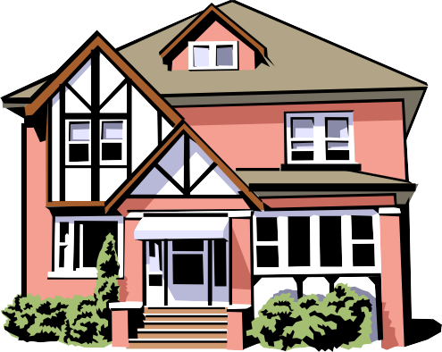
Oakwood Village wants to encourage Ward 4 homeowners to invest in your properties by assisting with improvement to the exterior of your homes. The “Exterior Maintenance Program” make grants available for you to improve the appearance of your home exterior while making our community more attractive and inspire a greater sense of neighborhood pride.

Project Description:

Contractor | Cost | Award Date | Date Certificated  by Building Dept

Signature:

Home Date

Updated May 17, 2019

Project Requirements:
- Program limited to single family owner-occupied homes. Proof of ownership is required. Please attach copies of
“mortgage or deed to property” or “2018 property tax bill”.
- Owners must be current with all Oakwood taxes and property taxes to be eligible.
- Your application, with supporting documentation, must be received by Friday, June 28, 2019.
- Two (2) bids are required. Please attached the bids to your application.
Contractors must be licensed, bonded, insured & registered with the Village of Oakwood.
- Hand deliver your application to the Oakwood Building Dept. at 23035(B) Broadway Avenue.
- Upon receipt of your application, the Oakwood Building Dept. will inspect your property, photograph your issues
associated with the workscope and forward all information to Village Council.
- Please allow 7 – 10 business days from the June 28, 2019 deadline for Village Council to review and to make a
determination as to whether the project qualifies. You will be contacted by phone, followed up by mail
and/or e‐mail concerning Council’s decision whether to award your project.

Funding for the Ward 4 Exterior Maintenance Program lasts for five (5) years. The total to be expended is
$80,000.00 in 2019 and $148,750.00 each year for the years 2020 thru 2023.
- Oakwood Village will reimburse seventy‐five (75%) percent of the approved construction cost of your project
up to a maximum reimbursement to you of $3,000.00 on a total project cost of $4,000.00.
- Eligibility is limited to one (1) award per address during the term of the program.
- Any applications not acted upon by Council, because authorized funding has been committed for the year,
will be carried over to the following year unless withdrawn by you.
- Village Council will approve applications based upon “need and necessity.”

Contractors shall not start work until the Building Dept. issues all necessary permits. The Village will waive

the cost of your building permit. All construction work must be completed within sixty (60) days of

the date of the award to you.
- When the contractor completes the project, you will contact the Building Dept. for its final review and
inspection of the contractor’s work. Upon the Building Department’s acceptance and approval of the
work, you will be issued a “Certificate of Project Completion and Acceptance.”
- Attached to this application is a “Waiver of Lien” form, which must be executed by the contractor when you
pay the contractor for the completed work; a copy of this executed “Waiver of Lien” form is to be
provided to the Building Dept. If a lien has been filed against the property by reason of the work
performed, you will be required to cooperate with the Building Dept. in obtaining and recording a valid
Release of Lien acceptable to the Village.
- A check for the reimbursement amount will be mailed to you within two (2) weeks after the Inspection
confirmation and contractor’s Waiver of Lien has been submitted to Oakwood Building Dept.
17. Eligible exterior improvements include roof repairs or chimney, siding repairs and/or painting, window
replacements, installation or repair of driveways, new shutters, gutters & downspouts, pruning or
removal of nuisance trees, etc.
 Ward 4 Maintenance Program
2

Waiver of Lien:
I, , owner of
hereby certifies that Homeowner: located at
Oakwood Village, Ohio 44146 has paid my company in full for the work perform pursuant to the Ward 4 Exterior Maintenance Program in the amount of and that all labor and materials associated with this project has been paid in full.

In consideration of the foregoing payment and other good and valuable consideration, the receipt of which is acknowledged, I expressly waive any right that my company or I now have, or in the future will have, to a mechanic’s lien against the foregoing real property and improvements on account of materials or labor furnished or to be furnished.

_______________________________________ _______________________________________________________
Date Contractor Signature

State Of Ohio )

County of
) SS:

Sworn to and subscribed in my presence this ___day of ________________ , 201__ .

____________________________________________________________________
Notary Public

Ward 4 Exterior Maintenance Program

3

