OAKWOOD VILLAGE

Community-Wide Yard Sale

August 17, 2019
  - Complete & submit the form to participate
The Village will provide  Advertising  and  Two Balloons  to be secured to your mail box.  Map & List of Addresses  Available at Village Hall  Free!  Questions? Contact Deb Hladky at 440.232.9988 email: dhladky@oakwoodvillageoh.com | 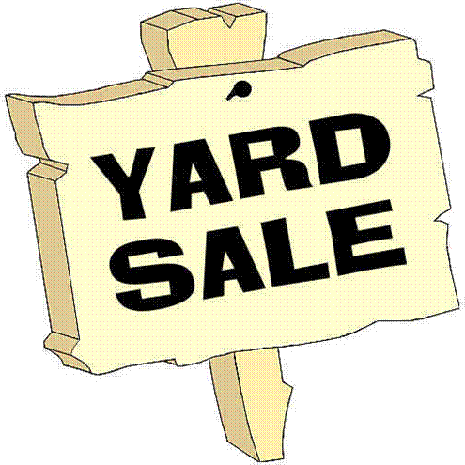

Complete the form enclosed and submit to Village Hall no later than August 1, 2019 (no exceptions)
Offices open 9 A.M. – 5 P.M. (Mon-Fri)
After hours, place your completed form in the night drop box located inside Village Hall.

Village of Oakwood

24800 Broadway | Oakwood Village, OH 44146 | 440.232.9988 | www.oakwoodvillageoh.com

Please print Legibly. The Village is not responsible for illegible handwriting

Name: ___________________________________________

(Will not be published – for office use only)

Address: _________________________________________

(Will be published)

Telephone No: ___________________________________

(Will not be published – for office use only)

Email:____________________________________________

(Will not be published – for office use only)

Items for Sale (optional)

Only list items which will legibly fit onto this form. Will be published in flyer.

________________________________________________________________________

________________________________________________________________________

________________________________________________________________________

________________________________________________________________________

________________________________________________________________________

________________________________________________________________________

________________________________________________________________________

________________________________________________________________________

________________________________________________________________________

Submit to Village Hall by August 1, 2019 – No Exceptions

