Tinker's Creek Cleanup
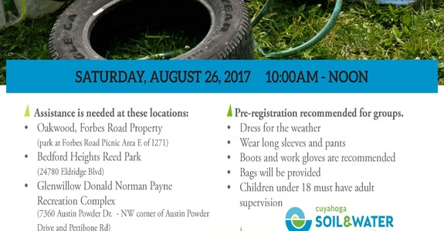

When: August 26 from 10:00am - 12:00pm
Where: Bedford Heights, Oakwood or Glenwillow, 5615 Perkins Rd Bedford Heights, OH 44128 map this
VOLUNTEERS NEEDED!!
Come join in this clean water initiative! Help protect our local streams and Lake Erie!
Assistance is needed at these locations:
- Oakwood, Forbes Road Property (park at Forbes Road Picnic Area E of I271)
- Bedford Heights Reed Park (5615 Perkins Rd)
- Glenwillow Donald Norman Payne Recreation Complex (NW corner of Austin Powder Drive and Pettibone Rd)
Details:
- Dress for the weather
- Wear long sleeves and pants
- Boots or work shoes are recommended
- Bags and work gloves will be provided (if you have work gloves, please bring them)
- Children under 18 must have adult supervision
- Pre-registration recommended for groups (below)
Contact:
- Jacki Zevenbergen, Cuyahoga SWCD
216/503-1338

Registration for Bedford Heights Cleanup Location
FREE

